Python User Guide

2.3.7 Health facility mapping
Python User Guide

Developer: UK ONS
Version 07/08/2026 - First Submission

Unit information
Section | Content
Unit ref and name: | 2.3.7 Health Facility Mapping
Developer country | UK
Tool name | Geospatial analysis of access to healthcare facilities
Version | 06/08/2026 - Version submitted for First round review
Tool byline | A generalisable healthcare accessibility tool that combines health facility locations, WorldPop population data, and road-network routing to estimate population who are outside a specified distance of a health facility.
Tool description | Effective delivery of healthcare services requires populations to have sufficient access to healthcare facilities. Accurate mapping of a country’s national health system infrastructure can improve planning and management for healthcare provision and ensure equitable resource distribution, particularly in response to epidemics and outbreaks. Unfortunately, many low and middle income countries (LMICs) lack such resources. This work is aimed at addressing this gap by providing a generalised tool for mapping healthcare facilities and their accessibility to populations in LMICs. The tool is designed to be flexible, allowing users to configure the analysis for different countries.  This tool generates a map of healthcare facilities with metrics of accessibility for local populations in LMICs. It combines:  - Georeferenced healthcare facilities  - Small area population estimates (WorldPop)  - Road network data (OpenStreetMap via Geofabrik)  Using road network routing software, the tool generates travel-time matrices between populated grid cells and healthcare facilities, then derives network distances from the travel times and presents them in an interactive dashboard.
Secondary title (optional) | N/A
Instructions front end (optional) | Quick Guide:  - Clone the repository  - Follow the instructions in the docs/R or docs/python folder to:  - Import and prepare the data  - Create the closest facility travel time matrix  - Run the Quarto dashboard and view the results  Detailed instructions can be found in the user guides or the docs/R or docs/python folders in the repository
Instructions back end (optional) | Dashboard guide  Identify estimated populations that reside within or beyond your selected distance of a health facility. The dropdown menus allow users to select individual subnational areas or the whole of the country. Healthcare facilities can be selected by type, for example: hospital, clinic, dispensary, private and unclassified. It also possible to choose estimated populations by subgroup:  - Females  - Males  - Children (0-14)  - Working-age adults (15-64)  - Older people (65+)  - Women of reproductive age (15-49)  Finally users can toggle between estimated populations that live *within* and *outside* the chosen distance of a healthcare facility.  The map will automatically zoom to the area of interest and update summary statistics in the right panel.
Link to tool | https://github.com/datasciencecampus/geospatial-healthcare-facilities
Tags | Practitioner, Tool, Geospatial, Health facility, Mapping, Accessibility, Data Science, UK, Malawi
Image of tool | 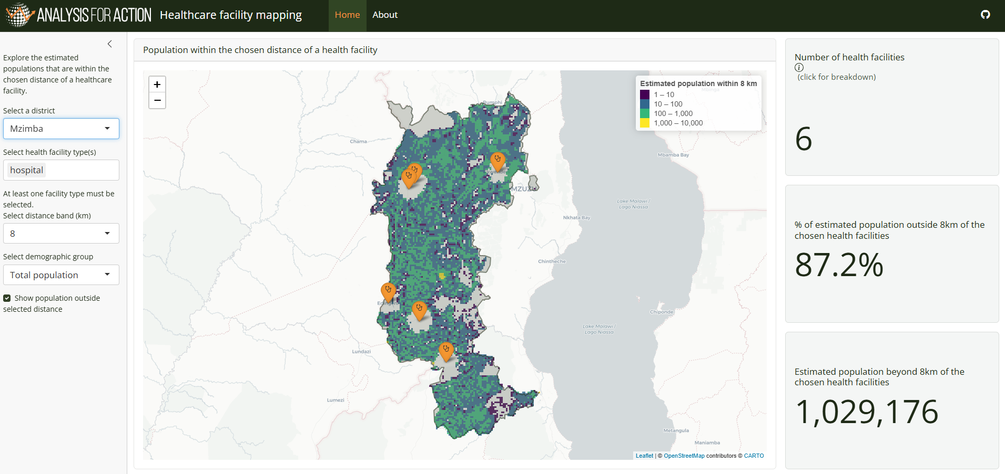

1. Introduction

1.1. What this guide is for
This guide covers how to install and run the Health Facility Mapping tool using the main python workflow.
This guide covers:
- Overview of the python workflow
- How to clone the repository
- Installation of packages
- Configuration for user specific contexts
- Running the pipeline, including:
  - Data preparation
  - Travel time analysis
  - Dashboard set up
- Troubleshooting

2. Python workflow overview

2.1. What this workflow does
The Python pipeline estimates travel times from populated grid cells to healthcare facilities across a road network, and presents the results in an interactive dashboard.

It combines:
- Road network data from OpenStreetMap (via Geofabrik)
- Gridded population estimates and demographic breakdowns from WorldPop
- Administrative boundaries from OpenStreetMap or a user-provided boundary file
- Health facility point data from a user-provided file or URL

2.3. Pipeline stages
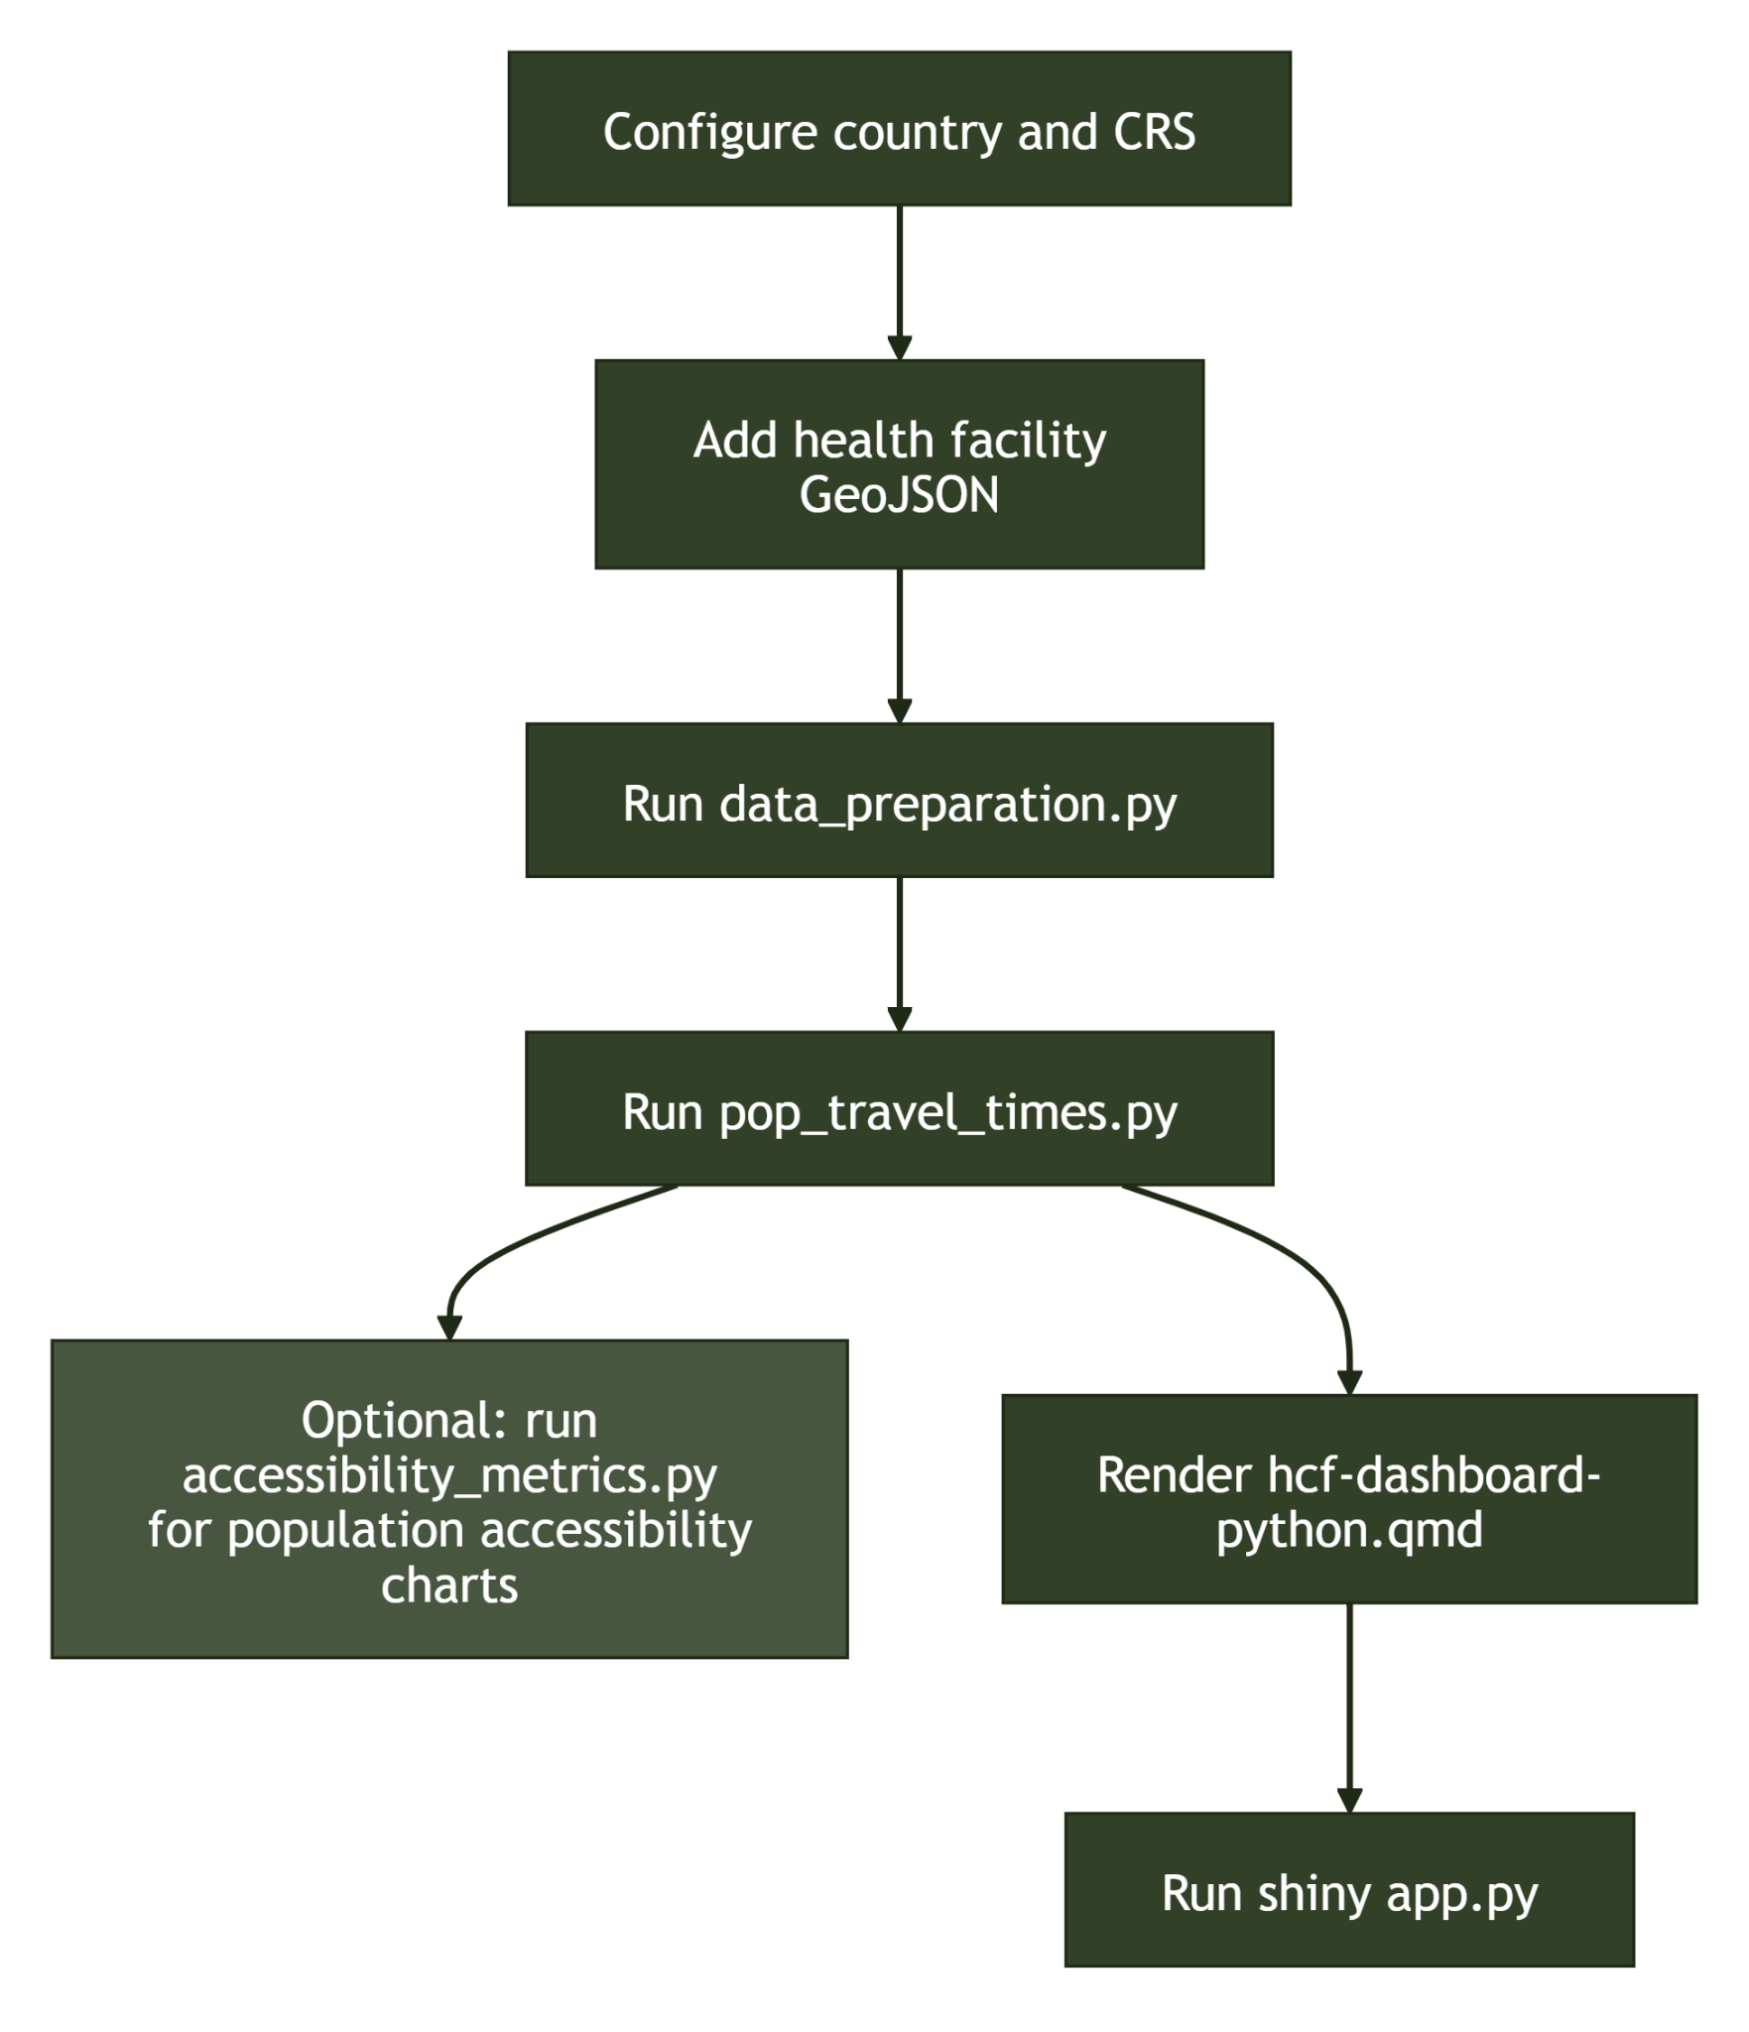

Stage | Script / file | Output
Data preparation | src/healthcare_accessibility/data_preparation.py | Processed GeoPackages
Travel time analysis | src/healthcare_accessibility/pop_travel_times.py | Parquet travel-time matrices + HTML maps
Optional post-processing | src/healthcare_accessibility/accessability_metrics.py | Population accessibility charts and summary views
Dashboard render | src/healthcare_accessibility/hcf-dashboard-python.qmd | app.py + static assets
Dashboard launch | src/healthcare_accessibility/app.py | Local Shiny web server

2.4. Technology stack
Component | Technology
Routing engine | r5py
Geospatial processing | geopandas, osmnx
Population rasters | rioxarray, geocube
Dashboard framework | Quarto + Shiny for Python
Mapping | Folium

3. Installation

3.1. Prerequisites
- Conda (recommended for geospatial dependencies)
- Quarto (required for dashboard rendering)

3.2. Cloning the repository
Clone the repository and move into the project folder:

terminal
git clone https://github.com/datasciencecampus/geospatial-healthcare-facilities.git
cd geospatial-healthcare-facilities

3.3. Python environment
Conda is recommended due to the number of geospatial packages that require compiled system libraries.

Within a Terminal navigate to the repository root and run:
terminal
conda env create -f environment.yml
conda activate hc-mapping

Then whilst still in the root folder, and in your chosen python environment, run the following in a terminal:

terminal
pip install -e .

The final pip install -e . installs the local healthcare_accessibility package in editable mode so that all scripts can import from it directly.
Alternatively:
If the above does not work, please try the following:
terminal
conda create -n hc-mapping python=3.11
conda activate hc-mapping
conda install -c conda-forge r5py osmnx pyrosm pyjanitor
pip install -r requirements.txt

Whilst in the root folder, and in your chosen python environment, run the following in a terminal:
terminal
pip install -e .

3.4. Quarto
Download and install Quarto from quarto.org, then verify it is on your PATH:
terminal
quarto --version

4. Configuration
All pipeline settings are read from configs/config.yaml. This file must be updated before running any scripts when adding a new country context.

4.1. Required settings

Country name
Set country to the full English name of your target country:
yaml
country: Nepal

Projected CRS
Add a projected CRS entry for the country under analysis_crs. This is used for all metric distance calculations.
yaml
analysis_crs:
Nepal: EPSG:24342

To find a suitable projected CRS, visit epsg.io and search <country> kind:PROJCRS.
Countries already configured in config.yaml:
Country | EPSG
Nepal | 24342
Bangladesh | 9678
Malawi | 20936
UK | 27700
Rwanda | 32736
Switzerland | 2056

4.2. Other settings
The following paths are set by default and should not normally need changing:
yaml
data_dir: data/
outputs_dir: outputs/
datasets_config: configs/datasets.yaml
visualisation_crs: EPSG:4326 # i.e WSG84

datasets_config points to configs/datasets.yaml, which maps logical dataset names to file paths relative to data_dir. If you restructure data directories, update this file rather than the scripts.

5. Data Preparation
The script src/healthcare_accessibility/data_preparation.py sources and processes all required input data into the correct format for travel time analysis. It automatically acquires OSM road data, WorldPop population grids, and administrative boundaries. Health facility data must be supplied manually.

5.1. Before running
Ensure you have:
- Activated the hc-mapping conda environment.
- Set country and analysis_crs in configs/config.yaml (see 4. Configuration).
- Placed health facility data at the expected path (see 5.5 Health facility data below).

5.2. OSM road network
OSM data is downloaded programmatically from Geofabrik into data/<country>/raw_data/.

For new countries, the country_continent_dict in src/healthcare_accessibility/data_preparation.py must be updated with the country name and its continent before the download will work:
python
country_continent_dict = {
"Malawi": "africa",
"Rwanda": "africa",
"Switzerland": "europe",
"Nepal": "asia",
"Bangladesh": "asia",
}

5.3. Population data
The default WorldPop data downloaded is the v1 release of R2025A for the year 2025. Release settings are controlled in define_wp_release_version inside src/healthcare_accessibility/data_processing_funcs.py.
To change the year or release, update the dictionary:
python
wp_release_details = {
"wp_population_data_year": "2026",
"wp_data_release": "R2025A",
"wp_data_version": "v1",
}

At the time of writing, R2025A v1 was the latest available for both aggregate population counts and age-sex population. Newer releases may be available, check the WorldPop Hub before running.
If the automatic download fails, retrieve the files manually from the links above and place them in data/<country>/raw_data/population_data/.
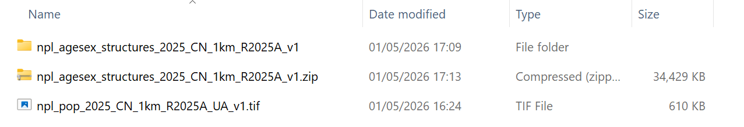

5.4. Administrative boundaries
ADM1 and ADM2 boundaries are downloaded automatically from geoBoundaries.org.

If the download fails, retrieve them manually from the country downloads page and place the files in data/<country>/raw_data/admin_boundary_geom/
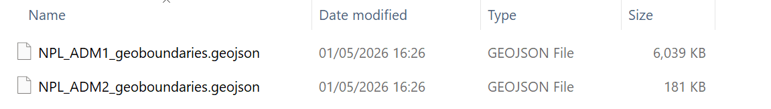

5.5. Health facility data
Automatic acquisition of health facility data is not supported. The file must be placed manually before running the script.

Expected path:
- data/<country-lower>/raw_data/health_facility_data/<country-lower>.geojson

Example for Nepal:
- data/nepal/raw_data/health_facility_data/nepal.geojson

Flexible source — healthsites.io via HDX
The data landscape for health facility datasets varies from country to country. In many cases, a publicly available register maintained by the relevant authorities (e.g. a national Ministry of Health) is likely to provide the most reliable source.

In an effort to create a generalised tool, we have identified the data from healthsites.io as a reasonable data source to experiment with initially. The advantages are that data is available for most countries around the world and is publicly downloadable from the Humanitarian Data Exchange (HDX) platform. The data can also be explored within healthsites.io to check for suitability before interacting with code.

Steps to download:
- Visit HDX.
- Search for <country> healthsites.
- Select the dataset tagged "Global Healthsites Mapping Project" (see screenshots below).
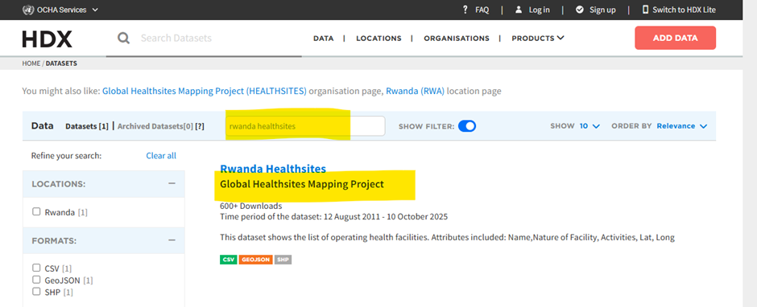
- Download the GeoJSON resource (e.g. <country>-healthsites-geojson).
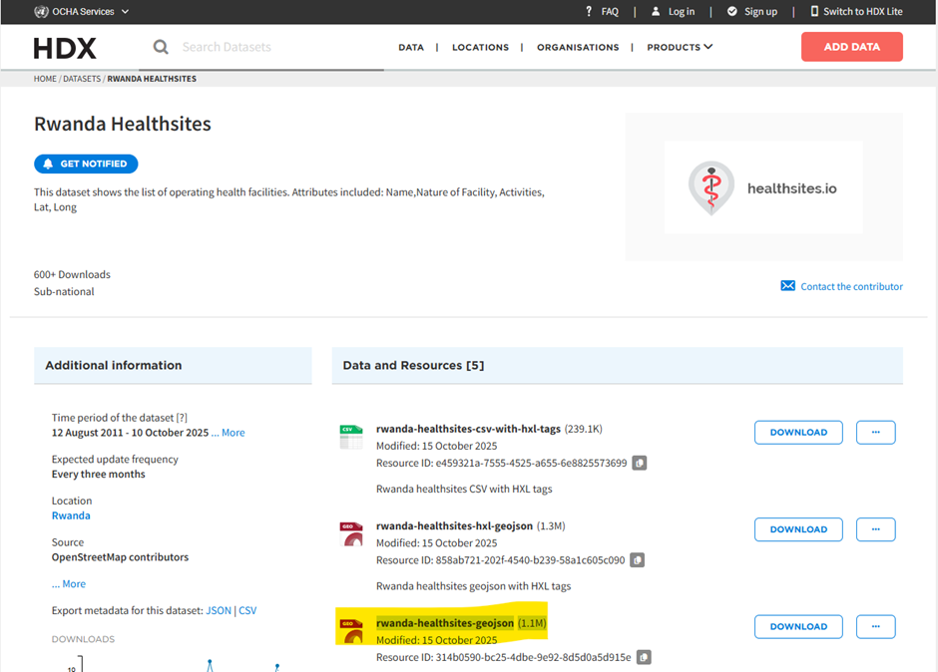
- Copy it to the expected path

Bespoke health facility datasets
If using a country-specific dataset, it will need to be processed into the format the pipeline expects.

Required columns (the presence of these two columns is essential for the pipeline to function):
- id — unique identifier for each facility
- geometry — point geometry (can be derived from lat/lon using geopandas points_from_xy)

Recommended columns (not required, but enable richer dashboard filtering):
- facility_name — e.g. "North-East Hospital"
- facility_type — e.g. "Hospital", "Clinic", "Pharmacy"
- facility_ownership — e.g. "Government", "Private"

These can provide interesting insight, but they are not essential for the pipeline to function.

Note - Data quality
There is no standardised approach to quality assure the health facility data within the codebase. The responsibility rests with the user to suitably quality assure any health facility data used for this analysis, preferably using local knowledge, and to understand its limitations, biases and implications. Known issues to look out for:
- Missing records
- Incorrectly located facilities
- Duplicate entries
- Implausible counts or distributions by type

5.6. Run the script
From the repository root:
terminal
python src/healthcare_accessibility/data_preparation.py

5.7. Validate outputs
After the script completes, confirm these files exist:
- data/<country>/raw_data/<country>-latest.osm.pbf
- data/<country>/processed_data/master_population_grid_data.gpkg
- data/<country>/processed_data/healthcare_facility_data.gpkg
- data/<country>/raw_data/admin_boundary_geom/<ISO3>_ADM1_geoboundaries.geojson
- data/<country>/raw_data/admin_boundary_geom/<ISO3>_ADM2_geoboundaries.geojson

6. Travel Time Analysis
Travel time estimation is carried out by pop_travel_times.py. It computes travel times between every populated grid cell and every healthcare facility along the road network, for each configured transport mode.

6.1. Before running
Ensure you have completed the data preparation step and all processed output files exist. See 5. Data preparation.

6.2. Adjustable parameters
The following variables near the top of src/healthcare_accessibility/pop_travel_times.py can be changed before running:

max_travel_time_mins
Sets the upper limit at which travel times are returned. Any routes beyond this threshold are excluded. Default is 120 (two hours).
- Increasing this value captures more origin-destination pairs but increases runtime and output file size.
- Decreasing it risks excluding journeys that fall within accessibility thresholds of interest.

At 120 minutes, approximate maximum travel distances are:
- Bicycle: ~24 km
- Walking: ~33 km

transport_modes_dict
Controls which transport modes are included. Default is bicycle only, which is also the minimum requirement for the downstream dashboard.
python
transport_modes_dict = {
"bicycle": r5py.TransportMode.BICYCLE,
# "car": r5py.TransportMode.CAR,
# "walk": r5py.TransportMode.WALK,
}

Car and walking modes are available but currently unsupported in the dashboard display. Uncomment to generate their parquet outputs.

6.3. Run the script
From the repository root:
terminal
python src/healthcare_accessibility/pop_travel_times.py

6.3. Outputs
Results are written to outputs/<country>/. For each active transport mode:
- <mode>_travel_times_to_All healthcare facilities.parquet — full origin-destination travel-time matrix (GZIP compressed)
- A national HTML travel-time map (note: national maps are large and may not load in most browsers)
- Per-ADM1 region HTML travel-time maps

6.4. Expected runtimes
These are indicative — actual times depend on available hardware and memory.
Country | Facilities | Grid cells | Mode | Approx. runtime | Notes
Rwanda | ~1.3K | ~26K | Bicycle | ~2 mins | -
Switzerland | ~6K | ~53K | Bicycle | ~30 mins | -
Nepal | ~6.8K | ~116K | Bicycle | ~1 hour | Requires >5.6GB RAM
Bangladesh | ~7.6K | ~156K | Bicycle | - | Memory errors observed at national scale

6.5. Scalability limitation and proposed solution
For large, densely populated countries the number of origin-destination pairs can exceed available memory at national scale.

The recommended approach is to segment the country into sub-national areas (for example by ADM1 region), run the analysis for each segment independently, and then recombine results.

Important
To avoid boundary effects where valid journeys near a segment border are missed, add a spatial buffer around each segment when clipping inputs. The buffer should comfortably exceed your largest accessibility threshold of interest, a buffer of 20 km is reasonable where 10 km thresholds are important. This will produce duplicate pairs across segment boundaries, so deduplication is required when recombining.

6.6. Optional extra: accessibility population charts
Outside of the core workflow, there is an additional script that can be run after travel-time analysis to generate extra accessibility outputs focused on population inclusion and exclusion.

Script:
- src/healthcare_accessibility/accessability_metrics.py

Run from repository root:
terminal
python src/healthcare_accessibility/accessability_metrics.py

What it provides:
- Charts of excluded population percentages by admin area (ADM1 and ADM2)
- Cumulative population accessibility charts by travel distance (and travel time where available)

When to run it:
- After pop_travel_times.py has completed successfully
- Optionally in parallel to dashboard work (for example in a separate terminal session)

Running in VS Code as notebook-style cells:
- The script includes # %% cell markers, so it can be executed step-by-step in VS Code's Interactive Window/Jupyter-style workflow.
- Open src/healthcare_accessibility/accessability_metrics.py in VS Code and run cells sequentially from top to bottom.
- This is useful if you want to test threshold/metric changes iteratively without restarting the full script each time.

Current script assumptions:
- Reads travel-time parquet files from outputs/<country>/
- Uses processed population and healthcare facility files from data/<country>/processed_data/
- Expects bicycle travel matrix and, in its current implementation, also references walking and car matrices when attaching mode-specific travel times

Key adjustable options in accessability_metrics.py:
- distance_threshold (default 10): controls the service-area threshold (km) used for excluded/included population summaries.

Related plotting controls:
- highlight_line: draws a vertical reference marker on cumulative plots.
- max_time and max_distance: set x-axis limits for time/distance chart variants.

Practical usage examples:
python
# Service area threshold used in excluded-population charts
distance_threshold = 10

Note
This script is optional and not required for the core workflow or dashboard creation.
The charts are displayed interactively (matplotlib) and are not automatically persisted as files unless you add save commands.

7. Dashboard
This guide explains how to render the Quarto dashboard (hcf-dashboard-python.qmd) and run it interactively via Shiny.

The dashboard visualises healthcare accessibility metrics interactively. It is built using a Quarto .qmd file backed by Shiny for Python, and is served locally via shiny run.

7.1. Prerequisites
The necessary software and packages must be installed. Please refer to 3. Installation for more information.

Required data outputs
The dashboard reads pre-computed travel time parquet files and processed geospatial data. Before rendering, you must have completed the full analysis pipeline so that the following exist for your configured country (e.g. Nepal):
- outputs/<country>/bicycle_travel_times_to_All healthcare facilities.parquet
- outputs/<country>/walk_travel_times_to_All healthcare facilities.parquet # optional
- outputs/<country>/car_travel_times_to_All healthcare facilities.parquet # optional
- data/<country>/processed_data/healthcare_facility_data.gpkg
- data/<country>/processed_data/master_population_grid_data.gpkg
- data/<country>/raw_data/admin_boundary_geom/<ISO3>_ADM2_geoboundaries.geojson

Refer to 5. Data preparation and 6. Travel time analysis for instructions on generating these files.

Configuration
Open configs/config.yaml and confirm the country field matches the context you want to visualise:
yaml
country: Malawi

All file paths in the dashboard are derived from this value. No changes to the .qmd file itself are required.

7.2. Step 1 - Render the dashboard
The dashboard uses Quarto's server: shiny mode, which means it cannot be rendered to a fully static HTML file that works offline. Instead, you render it into a bundle of assets that Shiny serves at runtime.

From the repository root:
terminal
quarto render src/healthcare_accessibility/hcf-dashboard-python.qmd

This produces:
- src/healthcare_accessibility/hcf-dashboard-python.html — the entry point
- src/healthcare_accessibility/hcf-dashboard-python_files/ — supporting JS/CSS assets

7.3. Step 2 - Launch with Shiny
From the repository root:
terminal
shiny run src/healthcare_accessibility/app.py

Open the URL printed in the terminal (typically http://localhost:<port>) in your browser.

What shiny run does
- Starts a local Shiny Python server using app.py, which was generated by the Quarto render step.
- Loads the setup chunk (data reading, config parsing) once on startup.
- Serves reactive UI elements (filters, map updates) in response to user input.

7.4. Interacting with the dashboard

Once open in a browser, the dashboard provides controls to filter and explore healthcare accessibility metrics:
Control | Description
Admin area selector | Filter to a specific ADM2 district or view nationally
Facility type filter | Select one or more healthcare facility types to restrict the map and summary statistics
Distance threshold | Set the km radius used to classify population as "within reach"
Travel mode selector | Switch between bicycle, walking, and car travel times (only available if the corresponding parquet file exists in outputs/<country>/)
Show outside toggle | Include or exclude population beyond the distance threshold
Facility breakdown button | View a count breakdown of facilities by type
Map | Interactive Folium map that updates in response to filters, showing facility locations and population grid cells coloured by travel distance

7.5. Re-rendering after changes
If you modify hcf-dashboard-python.qmd or any module in src/healthcare_accessibility/, re-run the render step then restart shiny run.

If the dashboard shows unexpected behaviour after re-rendering, clear the cached asset directory and re-render:
terminal
Remove-Item -Recurse -Force src/healthcare_accessibility/hcf-dashboard-python_files
quarto render src/healthcare_accessibility/hcf-dashboard-python.qmd
shiny run src/healthcare_accessibility/app.py

These files will be fully regenerated, deleting them causes no lasting harm.

8. Troubleshooting

8.1. Environment and installation
Problem | Likely cause | Fix
ModuleNotFoundError: healthcare_accessibility | Local package not installed | Run pip install -e . from the repository root
ModuleNotFoundError: r5py or osmnx | Conda packages missing | Run conda install -c conda-forge r5py osmnx in your environment
quarto: command not found | Quarto not on PATH | Install Quarto from quarto.org and restart your terminal

8.2. Data preparation (01_preprocess.R)
Problem | Likely cause | Fix
OSM download fails for a new country | Country not in country_continent_dict | Add the country and its continent to the dict in data_preparation.py
WorldPop download fails | Network issue or release no longer available | Manually download from WorldPop Hub and place in data/<country>/raw_data/population_data/
Admin boundary download fails | geoBoundaries API unavailable | Manually download from geoBoundaries country downloads and place in data/<country>/raw_data/admin_boundary_geom/
WorldPop download fails | Network issue or release no longer available | Manually download from WorldPop Hub and set population_filepath in config to the local zip file
FileNotFoundError for health facility GeoJSON | File not placed before running | Add <country-lower>.geojson to data/<country-lower>/raw_data/health_facility_data/

8.3. Travel time analysis (02_ttm.R)
Problem | Likely cause | Fix
Memory allocation error during routing | Too many origin-destination pairs for available RAM | Reduce max_travel_time_mins, run one mode at a time, or segment analysis by ADM1 with a buffer (see 6. Travel time analysis)
Output parquet files are missing | Script did not complete successfully | Check terminal output for errors and re-run
Very long runtime | Large country with dense population and road network | Expected - see runtime estimates in 6. Travel time analysis

8.4. Dashboard
Problem | Likely cause | Fix
FileNotFoundError on dashboard startup | Missing parquet or .gpkg file | Complete the full pipeline first; confirm country in configs/config.yaml matches your output folders
Dashboard loads but map is blank | Empty data or CRS mismatch | Verify processed data files contain rows for the configured country
Shiny server port conflict | Another process on the default port | Pass --port <number> to shiny run, e.g. shiny run src/healthcare_accessibility/app.py --port 8081
Unexpected behaviour after re-render | Stale cached asset files | Delete hcf-dashboard-python_files/ and re-run render and shiny run

References
- References appear in a list in the Vancouver style.

